**“Stick your neck out…it’s a lot more fun than sitting at home and watching other people do it.”**   
– Sir Richard Branson

****I've always admired people who can talk well publicly. It combines a lot of skills that you need to succeed in life. Confidence, great communication skills, ability to put yourself in someone else's shoes and above all ability to connect with others. Over the years I realised that public speaking is not a talent one is born with. It is developed through constant practice and scrutiny.

I had heard that 27 is the age your life really falls in place. You're more comfortable with your job, social life and other responsibilities. However, as I turned 27, I realized that the drastic change that I envisioned my life to magically experience did not take place. You read so many inspirational quotes that lift your spirit just for a little bit but most of the time, these quotes are just words. They will have no effect on your life until you take charge and decide to change it yourself for the better.

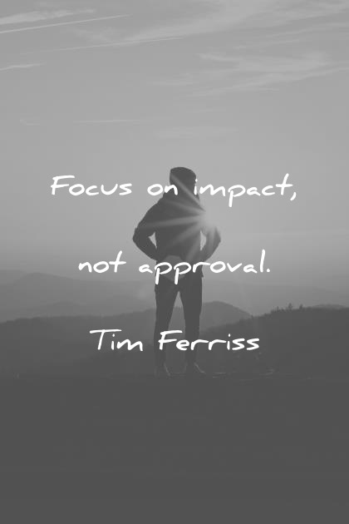As I had already noticed the qualities of a good public speaker as mentioned earlier, I decided that its time to get out of my comfort zone. I was reading the book, 'The 4-hour Work Week' at the time, in which the author Tim Ferriss encourages his readers to do a few comfort challenges. They are designed to put you outside of your comfort zone. One of them involves learning how to become comfortable with getting 'No' for an answer. In this challenge, you are asked to go into a coffee shop and ask for a discount. It seems simple enough but to most people, the idea of being said no to, is terrifying. Another comfort challenge involves randomly lying down on the ground in public, just lay there for 2 minutes and then get up and start walking like nothing happened. This one is supposed to help you deal with being ridiculed or judged. Although I didn't opt for any of these extreme comfort challenges, I decided to commit to giving my 100% to one year of Toastmasters, to begin with.

It has been 9 nine months since I joined the Toastmasters journey. In this short period, I've been appointed the Club Secretary, which has substantially improved my leadership skills. For my icebreaker speech, I was shaking from head to toe and my voice quivered. For my P2, I gave a speech about a topic I really cared about but forgot half my speech. These are not encouraging examples of conquering your fears but these are steps you will have to take to reach where you want to be.

After my second speech, I tweeted at my role model, the author Tim Ferriss himself. I said 'Joined Toastmasters after listening to you. Gave my second speech yesterday which was pretty bad but I can feel the fear loosening its grip!' The next morning, I wake up to a reply which read 'Huge congrats!' It was a congratulatory message for having tried to get over my fears, not for being a great speaker, which I found so encouraging. Had I not taken up this challenge, I wouldn't have experienced the happiness that Tim Ferriss' reply brought me. So what I'm trying to say is, there is nothing to lose but everything to gain!

**Chaitanya KrishnaKumar**

**Emirates Toastmasters Club**

**Runner Up – Divn F Solo Writing Competition**

